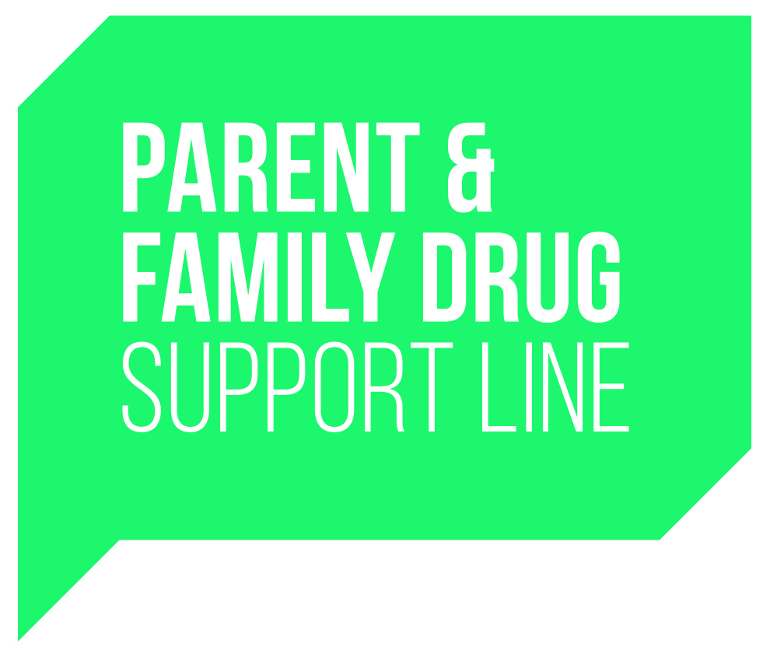

Parent and Family Drug Support
Application Form
Parent Support Network

Name:
Address:
Suburb: | Postcode:
Contact Phone: (H) (W)
Email: (lower case) | Mobile:

Gender: (please tick) | Male: | Female:

Please briefly describe your experience with problems in relation to your son/daughter’s alcohol and/or drug use (when did it start? What impact did it have? How did you cope? How did others in your family cope? What helped? What didn’t help?)
____________________________________________________________________________________________________________________________________________________________________________________________________________________________________________________________________________________________________________________________________________________________________________________________________________________________________________________________
______________________________________________________________________________________________________________________________________________________________________________________________________________________________________________________________________________________________________________________________________________________________________________________________________________________________________________________________________________________________________________________________________
Are these problems ongoing for you? If yes, please comment on how these problems are impacting on you/your family at present
______________________________________________________________________________________________________________________________________________________________________________________________________________________________________________________________________________________________________________________________________________________________________________________________________________________________________________________________________________________________________________________________________

Please describe what services, treatment, information, tips, ideas and strategies you think have helped and supported you and your family the most?
__________________________________________________________________________________________________________________________________________________________________________________________________________________________________________________________________________________________________________________________________________________________________________________________________________________________________________________________________________________________________________________________________________________________________________________________________________________________________________________________________________________________

What motivated you to apply for this position? Why now and what do you hope to gain from the experience?

_____________________________________________________________________________________________________________________________________________________________________________________________________________________________________________________________________________________________________________________________________________________________________________________________________________________

Do you have any previous volunteer work, paid work or education/training that you believe is relevant to the role of a Parent Peer Volunteer? What skills and qualities do you think you could bring to the service?
__________________________________________________________________________________________________________________________________________________________________________________________________________________________________________________________________________________________________________________________________________________________________________________
In addition to providing telephone support, please indicate (by ticking the box) which other areas, if any, you may be interested in:

Perth Drug Court (Tuesday morning)
Support Group Facilitation

Please indicate your availability for the telephone roster by placing a TICK () in the appropriate boxes below. Please note that often we need to fill more gaps on the roster during office hours than evening shifts. If and when necessary we can be somewhat flexible with start and finish times.

 | Monday | Tuesday | Wednesday | Thursday | Friday | Saturday | Sunday
Morning 8am – 1pm
Afternoon 1pm – 6pm
Evening 6pm – 10pm

Are you able to attend team meetings on weekday evenings (6.30 – 8.30pm) once every 6 weeks?
Yes No

Do you have access to an email account and a reliable telephone network?
Yes No

Can you please let us know how you found out about this role?
_________________________________________________________________________________
11. Is there anything else you wish to add?
_________________________________________________________________________________Please give details of two people able to give Character References who may be contacted; one of which should be a close family member or someone who has known you personally for a long time.
1. Name:________________________________ 2. Name:______________________________
Telephone:____________________________ Telephone:___________________________
Relationship to applicant:_________________ Relationship to applicant:________________
Would you be happy to undergo a basic criminal record screening of which would be paid for by MHC? Yes No
Please sign this form
Name: _________________________________________
Signature: _________________________________________
Date: _________________________________________

Please send to: Parent and Family Drug Support Coordinator
Mental Health Commission
PO Box X2299
Perth Business Centre WA 6847
Or reply by email to: parentdrugsupport@mhc.wa.gov.au
Closing date: Monday 6th April 2020

