Resource Order Form
The Here For You Support Line has a DL brochure and wallet card aimed at assisting people to access our services. Here For You is state-wide, confidential and available 7am-10pm via phone. Access can also be made via Live Chat and email. TIS and TTY are also available.
Please note that limits apply to the number of items that can be ordered. If you require additional copies please contact Here For You (details below). Please allow 14 days for delivery.

 | DL Brochure | Wallet Card
 | 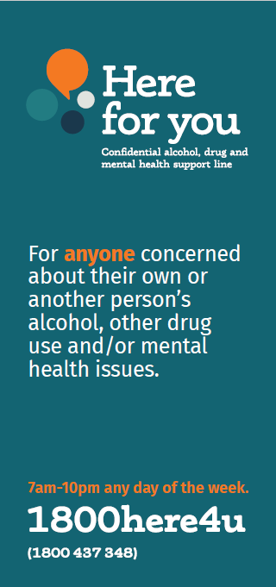 | 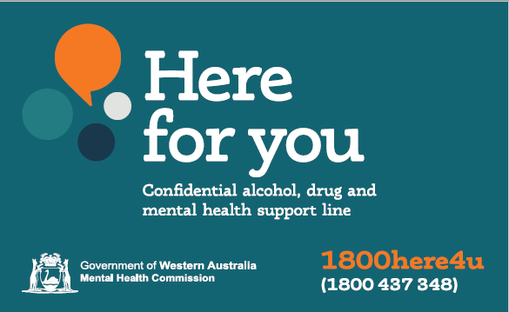  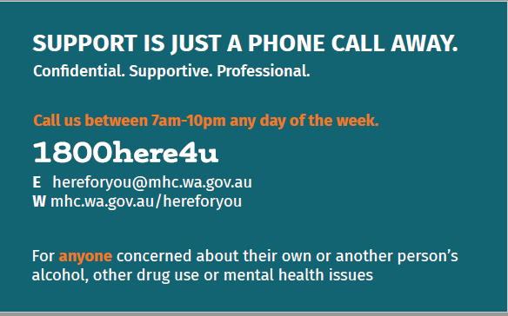
 | (Max quantity 100) | (Max quantity 100)
Order Quantity:

Order Details
Title: | Mr Mrs Ms Miss Dr Other
Name:
Occupation:
Organisation:
Address:
Telephone:
Email:

Please return your completed form to:
Email: hereforyou@mhc.wa.gov.au Fax: 9442 5020 Mail: Here For You
Mental Health Commission
PO Box X2299
Perth Business Centre WA 6847

